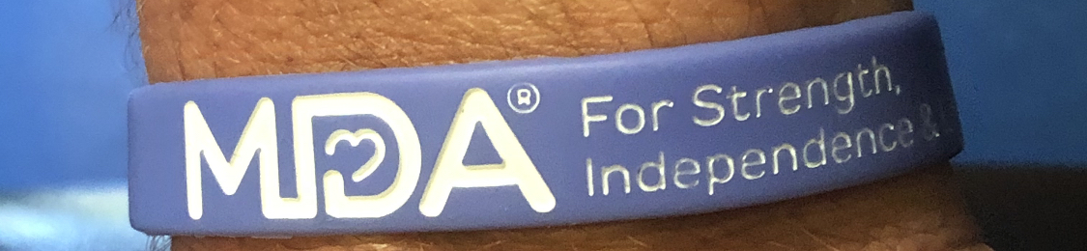

To get yours and help NJ Merged Branch 38 support MDA, please contact Armando Pedreira 38apedreira@gmail.com

